Photo Consent
Tuesday 10th October, 2023
Dear parents and carers,

We really want to be able to share as much as possible about your child’s education with you and the wider community; but we also want to make sure that we act safely and responsibly.

To support us with this, we need your consent to share images of your child in a small number of specific circumstances. We would hope that you are comfortable with all of the following, but we understand that for some families and children this might not be possible.

Please review the following list, tick as appropriate, and let us have a copy back. You can also complete this form online here: https://forms.gle/gWAn3nhN3SudC48b8

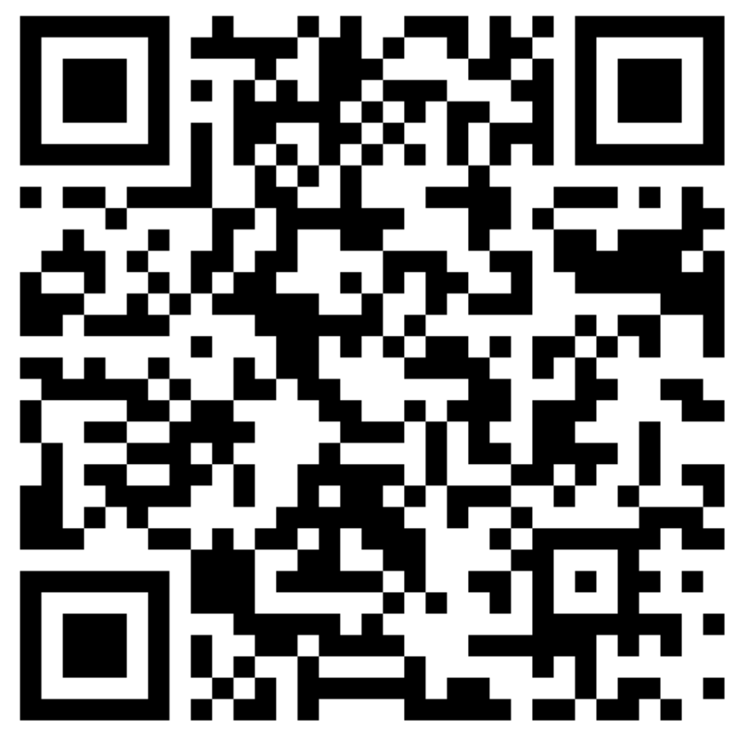

We appreciate that you may have already done this, but it’s important that we have an up to date record, and there are some new and different options on the form below.

Yours Sincerely,
Mr R. Lewis
Headteacher

I agree to consent to images of my child being used on: | Agree | Disagree
The School and/or trust website
The school and/or Trusts Social Media
Newsletters and other printed correspondence
School prospectus, leaflets and/or brochures
Printed banners and signs
In and around the school building (including floor books or other shared work)
All of the above

Parent/carer signature ……………………………………… Date …………………

